**TEST PLAN**



**Author: Tai Nguyen**

**Date: 10/27/2016**

**Revision history**

|  |  |  |  |
| --- | --- | --- | --- |
| **Version** | **Date** | **Author** | **Notes** |
| **1.0** | 10/27/2016 | Tai Nguyen | Create document |

Contents

I. TEST PLAN INDENTIFIER 3

Imagineer-TestPlan-1.0 3

II. INTRODUCTION 3

1. Nature of the Project 3

2. System Test Objectives and Scope 3

III. ITEMS TO BE TESTED 3

IV. FEATURE TO BE TESTED 4

V. APPROACH 4

VI. PASS/FAIL CRITERIA 6

VII. SUSPEND/RESUME CRITERIA 6

VIII. TEST DELIVERABLES 6

IX. TESTING TASKS 7

X. THE TESTING ENVIRONMENT 8

XI. RESPONSIBILITIES 8

XII. STAFFING AND TRAINING NEEDS 8

XIII. SCHEDULING 8

XIV. RISK AND CONTINGENCIES 9

XV. SYSTEM TEST COSTS 9

XVI. TEST PROCESS DIAGRAM 10

# TEST PLAN INDENTIFIER

## Imagineer-TestPlan-1.0

# INTRODUCTION

## Nature of the Project

Our team will be able to develop the Vinaswap project which is a a community website to help registered users (Vinaswap members) swap and barter skills without paying any fees or money in 30 weeks. We created a initial scope for the project. All the detail information about the project will be written on the project plan.

## System Test Objectives and Scope

Documents describing test execution environment, the activities related to the test, tasks and schedules to perform the test. The goal will meet the expectations following:

* The main functions needed to be put in check exactly as required by the customer.
* The software meets the requirements and its effectiveness.
* To meet the ease of use and maintenance of software.

# ITEMS TO BE TESTED

All items constituting software systems "VINA SWAP" will be during System Test Test to ensure that the project team to comply with customer requirements.

The functions listed below can code and version number. But this position constitutes a verifiable configuration software "VINA SWAP".

Conducting test items constituting software "VINA SWAP" to ensure customer requirements according to tests conducted hang.

|  |  |  |
| --- | --- | --- |
| **Function Name** | **Indentifier** | **Version** |
| Manage account | User | 1.0 |
| Search skill | User | 1.0 |
| Add information | User | 1.0 |
| Upload photo | User | 1.0 |
| Upload videos | User | 1.0 |
| Manage accounts | Admin | 1.0 |
| Manage all listings | Admin | 1.0 |
| Manage website the information | Admin | 1.0 |
| Perform matching offers and needs | Admin | 1.0 |

***Table 1 : Table Items to be Tested.***

# FEATURE TO BE TESTED

List function test compared with design specification:

|  |  |
| --- | --- |
| **Feature** | **Design Spec.Identifier** |
|  |  |
|  |  |

***Table 2: Features to Be Tested***

# APPROACH

* The group will use existing resources to software testing.
* To ensure it meets the quality requirements, the testing process will focus groups to work together to facilitate exchange and solve problems encountered.
* Individuals will examine each part of the system and will be the other members took turns reviewing to avoid deficiencies.
* The program will be tested in the environment of use (Windows/IOS).

1. **Sources of sample domain data and test Oracles**

* Scrum team will provide input data and test scheduling.
* Output will be described and stored for comparison with later tests, help assess more accurate system.

1. **Staff**

|  |  |  |  |
| --- | --- | --- | --- |
| **No** | **Name** | **Task** | **Notes** |
| **1** | Tai Nguyen | Scrum team | Test management, group management members and group meetings prepared |
| **2** | Phuong Nguyen | Scrum team | Perform testcase và review |
| **3** | Thach Nguyen | Scrum team | Perform testcase |
| **4** | Viet Dang | Scrum team | Perform testcase |
| **5** | Quang Nguyen | Scrum team | Perform testcase |
| **6** | Chanh Tran | Scrum team | Perform testcase |

***Table 3: Staff***

1. **Record Keeping**

* All relevant documents and data obtained during the test team will save on Team Services to the members can work together to monitor and respond quickly.
* The data files will be sorted by sprint, the errors found will be described and assessed the severity affect project.

1. **Test status**

System status will be monitored through regular team meetings, team leader will notify the current status quo and find statistical errors in sprint.

1. **Test tools**

All team members will use these tools to test application software systems new: Team Services Test Hub.

1. **Stop-Test Criteria**

Group ended testing process based on the data after the gain of all the functions of the software, then make a list of errors. The section will be judged guilty severity based on the possibility occur. The group will accept low-level errors have little impact on users.

* Critical: This is an error that must be corrected immediately, as it could cause significant impact to product damage.
* High: These errors affect the main functions of the product.
* Medium: These small errors it affected by the removal request.
* Low: The bug affected a small, little impact to the product.

1. **Types of system test**

* FUNCTIONAL TESTING: Test all functions as required. The test case does not pass will be saved to the defect and will be repaired to meet customer requirements.
* PERFORMANCE TESTING: Test the feedback interactions between software products to users.

# PASS/FAIL CRITERIA

This document describes the severity of the error and the failure of application software projects "VINA SWAP". The scope is determined by a scale starting at 1; each failure will have a level of influence on specific system or user software. Errors may occur when the Test does not matter, does not lie in high value on the measure, but must be addressed and recorded. Making statements on issues error test are completed for the observed failure. All cases detected error to extend the development or repair after, because soon test next is the group's Regression Test.

# SUSPEND/RESUME CRITERIA

The test work will be stopped at the end of workday. All documents will be saved test and submitted to Team Services (VinaSwap project). And test work will continue on the next working day. However, the test will stop when falling into one of the following situations:

* The software interface is not currently operating.
* Database errors.
* Hardware Failure.
* The built should be repaired.

Team will be based on the percentage of error occurs when the test system to evaluate applications in four levels:

* Level 1 : <20% (Do not stop the test and send one member fixes)
* Level 2 : 20% - 50% (Stop the program and fixes)
* Level 3 : >80% (Start over).

When the Sprint pack faulty function in large and can not be fixed, then Sprint will be demolished, rebuilt and a new Sprint continues the implementation process (design-code-Continuously-test).

# TEST DELIVERABLES

|  |  |  |
| --- | --- | --- |
| **No** | **Name** | **Describe** |
| **1** | Test plan | This document describes detailed test plans and methods for conducting a test of the group based on the resources, tools have been identified. |
| **2** | Bug defect tracking | List testcase fail and cancel. The number testcase fail of total testcase. Detailed list of those tests. |
| **3** | Test Report | This document describes all of the test results as well as an overall rating of the group. |
| **4** | Function test | Details of the test module, the test function pass, fail and cancel. |
| **5** | Non-function test | Details of the non-functional testing of software. |

***Table 4: Testing Deliverable***

# TESTING TASKS

|  |  |
| --- | --- |
| **Task** | **Scrum team** |
| Write Testcase | x |
| Test preparation environment | X |
| Execute the test case | X |
| Report written after execution | X |

***Table 5: Testing Tasks***

List of things to do when conducting a test:

* Prepare test plans and attachments.
* Preparation of specifications for the design testing process.
* Prepare test specification document.
* Monitoring reports will be delivered.
* Preparation of test scripts and tools for testing.
* Conduct functional tests (functional tests) and record the results.
* Conduct performance tests (performance tests) and test stability (stress tests) and record the results.
* Conduct security testing (security tests) and regression testing (regression tests) and record the results.
* Delivery of materials testing for the configuration management.
* Supervise those conducting the test and reorder when testing measurements.
* Prepare and participate in the conference test status report.
* Prepare summary report test results.

# THE TESTING ENVIRONMENT

|  |  |  |  |
| --- | --- | --- | --- |
| **No** | **Test items** | **Hardware** | **Software** |
| **1** | Work station | * Windows 8, 10, IOS | PC/Laptop :   * Hard disk space:4GB * Memory: more than 512 MB * CPU: Intel Core i3,i5 and more |
| **2** | Development languages, Databases, Application server | * MS SQL Server 2012 * MVC Framework |

***Table 6: Testing Environment***

# RESPONSIBILITIES

|  |  |  |  |
| --- | --- | --- | --- |
| **No** | **Roles** | **Responsibility** | **Assign** |
| **1** | Scrum team | The test plan will establish, control tester, test and report the results. | Scrum team |
| **2** | Scrum team | Generate test cases, test cases and test it | Scrum team |
| **3** | Scrum team | Testing and debugging | Scrum team |

***Table 7: Responsibilities***

# STAFFING AND TRAINING NEEDS

Qualification test of weak groups do not practice as much. Therefore it is necessary to make the test group meeting more and clear division of work for each member do to improve proficiency test. This will help to complete the application process takes place according to the schedule of the project.

# SCHEDULING

|  |  |  |  |  |
| --- | --- | --- | --- | --- |
| **No** | **Task description** | **Start date** | **Finish date** | **Assign to** |
|  |  |  |  |  |
|  |  |  |  |  |
|  |  |  |  |  |

***Table 8: Scheduling***

# RISK AND CONTINGENCIES

* The customer does not have time to put the data to test case. (Find ways to communicate with customers in a variety of media such as email, message....)
* The members of the team during the test conflict. (When a conflict or disagreement test case members may take the vote both teams.)
* Duration of the code is too limited to affect the test of time. (As time limited test, we just test the most important functions that allow time to ensure the best possible requirements)
* Ability to test the weak members.

# SYSTEM TEST COSTS

Test Costs are costs for money wages to members perform the testing. Because the size of the project using Scrum model should be used Team Services (5 people use free and user 6 rental cost $5).

# TEST PROCESS DIAGRAM

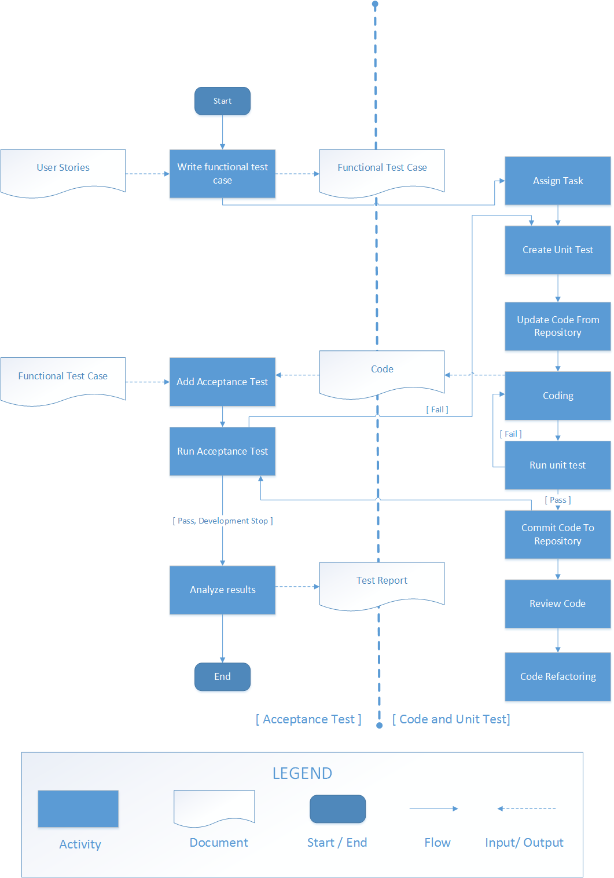

***(Reference models, redesigned by Nguyen Huu Tai)***

**Description :**

* Step 1 : Start test, write functional test case, input user stories, write test case and output list test case.
* Step 2 : Assign Task, based on test case filter list through the functions.
* Step 3 : Create Unit Test, based on the functional requirements of the developer who wrote the list test case Unit tests (WhiteBox Test).
* Step 4 : Update code from repository, updated according to unit test code in the step above and save repository.
* Step 5 : Coding, developers write code program complete.
* Step 6 : Add acceptance test, input code of step 5 and functional test case of step 1, prepare test environment complete.
* Step 7 : Run acceptance test, test function complete (if function fail, developer will be repair functions complete and transfer code complete from step commit code to repository in this step) with list test case (BlackBox Test).
* Step 8 : Analyze results, analyze, evaluate, synthesize test the process and output test reports.